BIO-DATA
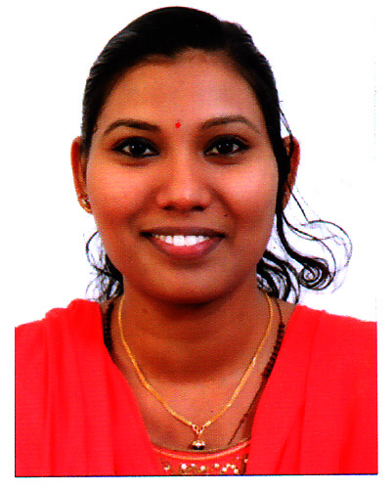
1. Name : RINU C. W
2. Husband’s Name : Jaison A. J
3. Date of birth : 04.10.1989
4. Age in yrs : 31 yrs
5. Sex : Female
6. Marital Status : Married
7. Religion & Caste : Christian, Latin Catholic
8. Nationality : Indian
9. Address for communication : Murukumthara house , 10/241 (A),
Indira Lane , Chullickal , Kochin – 5
Pin - 682005

10. Contact Number : 9778058021 , 9061185528
11. Email ID : mariarinu17@gmail.com

12. Educational qualification

Sl. No | Exam passed | Year of passing | University/Board | Name of  Institution | Percentage
1. | Degree  (B.Sc Zoology) | 2010 | M.G .University | The Cochin College , Mattancherry | 81%
2. | Plus two | 2007 | Board of Higher Secondary Examination | Santa Cruz Higher Secondary School , Fort kochi | 70%
3. | SSLC | 2005 | Board of Public Examination | O.L.C.G.H.S  Thoppumpady | 75%

13. TECHNICAL QUALIFICATIONS :

- COMPUTER BASICS, M.S OFFICE

- D.O.A. (Diploma in Office Automation)

- DATA ENTRY

- ADOBE PAGEMAKER, ADOBE PHOTOSHOP , CHEM-BIODRAW

14. LANGUAGES KNOWN : ENGLISH, MALAYALAM, HINDI.

15. AREA OF INTERESTS : READING , DRAWING, LISTENING MUSIC .

16. PREVIOUS EXPERIENCE

- 6 MONTHS OF EXPERIENCE AS A TEACHER IN JAM-ATH RESIDENTIAL PUBLIC SCHOOL, PADAMUKAL.

- 5 YEAR AND 10 MONTHS OF WORKING EXPERIENCE AS AN ACADEMECIAN IN RESEARCHWORLD ERNAKULAM. (Coaching centre for CSIR/UGC/NET Exam).

- 2 YEAR AND 8 MONTHS OF WORKING EXPERIENCE AS AN OFFICE STAFF IN FRIENDS ASSOCIATES PANAMPALLY NAGAR , ERNAKULAM (ICICI BANK Verification Office).

Declaration

I, hereby declare that the statement mentioned above are true to the best of my knowledge and can be supported by relevant documents .

Place : CHULLICKAL
Date : RINU C. W

